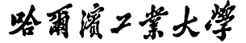


Report of Software Architecture

Homework 3.1-1: Composite Pattern

Basic information
Team name： _______________________________
Class number: ___________________________________________________
Department/school：
Team members with student numbers：

_______________________

Instructor’s comments and score
Comments：

Score：
Signature of the Instructor：

Year Month Date
作业要求：Study the following figure about the Composite solution of the Air force formation problem. Also you can read the source code about the implementation of the problem. Then,
- Run the program first to be familiar with the program;
- In the design diagram below, add a class named Wing, which is also considered as an Air force unit. Write code for the class Wing. Note that class Wing is parallel to class Squadron and Group, that is, class Wing will also extend class AirUnit. The class has been half-written for you (see it in this package). The object of this class will contain 162 fighters, 18 bombers, 18 transporters and 18 eAirplanes;
- Once you correctly write code for class Wing, compile it and then you don’t need to do anything else. Other parts of the program have been well written for you. You run the program and see how it works.

AirUnit
Airforce
+fight()
Fighter
+fight()
Squadron
Group
+fight()
+add()
+remove()
+getChild()
-a: ArrayList
Bomber
+fight()
Transporter
+fight()
EPlane
+fight()
F16
+fight()
F15
+fight()
F22
+fight()
B1B
B2A
+fight()
+fight()
B52
+fight()
C130J
+fight()
C130E
+fight()
CV22
+fight()
E9A
EC130
+fight()
+fight()
AirforceGUI
+main()

Figure 1. Air Force Formation Program- Composite pattern

- Answer the following questions
    - What class have you added to the design diagram?
    - What classes have been modified?
    - Correctly draw your new class diagram

- In the user interface, you choose “SQUADRON”
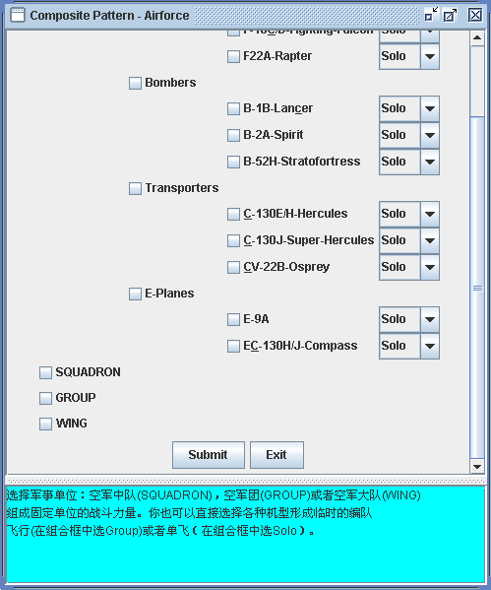
and then click on Submit. Write down all the methods that have been invoked by this action sequentially (in what class, what method has been called).

- How class AirUnit works in forming the air unit such as squadron, group or wing?

- (Testing your program) Typical input and output from running your finished program

